**An Efficient and Effective Automated Lane Detection Model for Autonomous Vehicles Using OpenCV and Python**

Raksha Sankhala[1], Saquib Qureshi[2], Saiel Wadwekar[3], Yashasvi Sharma[4], Yashraj Sharma[5], Yuvraj Singh Panwar[6], Pawan Kumar Gupta[7]

Information Technology, Acropolis Institute of Technology and Research, India

[vinisha18.sankhala@gmail.com](mailto:vinisha18.sankhala@gmail.com)[1], saquibqureshi17@gmail[2], [saiel69@gmail.com](mailto:saiel69@gmail.com)[3], [sharmayashasvi.124@gmail.com[4], yashrajsharma141@gmail.com[5]](mailto:sharmayashasvi.124@gmail.com[4],%20yashrajsharma141@gmail.com[5]), [yuvrajsinghpanwar12@gmail.com[6](mailto:yuvrajsinghpanwar12@gmail.com[6)], pawankumargupta@cropolis.in[7].

**Abstract:**

Lane detection is a challenging problem. For several decades’ lane detection has attracted the attention of the community of computer vision. Essentially, lane detection is a multi-feature detection problem that has become a real challenge for computer vision and machine learning techniques. We know that many methods of machine learning are used for lane detection but mainly they are used for classification moreover feature design. Modern methods of machine learning can be used to identify the features which are rich in recognition and have achieved success in detection tests. However, the fully flashed implemented in the efficiency and accuracy of lane detection is not achieved. In this paper, we propose a new method to solve it. We would like to introduce another method of preprocessing and ROI selection. The main goal is to use the HSV color transformation to extract the white features and add preliminary edge feature detection in the preprocessing stage and then select ROI on the basis of the proposed preprocessing. This new method of preprocessing is used to detect lane.

**Keywords:** ***Lane Detection, Lane Simulation, Hough Line Detection, Canny Edge Detection, Overlay Detected Line, Color Filtering in HLS***

1. **Introduction**

In a scenario of driving, lane lines are an essential part of indicating the way traffic flow and where a vehicle should drive. It's also an important starting point when the concept of a self-driving car is examined. In this paper, we’ll be demonstrating important aspects to build your own lane detection system in OpenCV using Python. The structure of a lane detection is pipelined as:

• Reading Images

• Color Filtering in HLS

• Region of Interest

• Canny Edge Detection

• Hough Line Detection

• Line Filtering & Averaging

• Overlay detected lane

• Applying to Video

With the fast development of society, vehicles became one among the transportation tools for folks to travel. within the slim road, there area unit a lot of and a lot of vehicles of every kind. As a lot of and a lot of vehicles area unit driving on the road, the number of victims of automotive accidents is increasing each year. the way to drive safely underneath the condition of various vehicles and slim roads has become the main target of attention. Advanced driver helps systems that embody lane departure warning (LDW), Lane Keeping Assist, and adjustive control (ACC) will facilitate folks analyze the present driving surroundings and supply applicable feedback for safe driving or alert the motive force in dangerous circumstances. this sort of auxiliary driving system is predicted to become a lot of and a lot of good.

Lane detection may be a hot topic within the field of machine learning and pc vision and has been applied in intelligent vehicle systems. The lane detection system comes from lane markers in very complicated surroundings and is employed to estimate the vehicle’s position and flight relative to the lane faithfully. At identical time, lane detection plays a very important role within the lane departure warning system. The lane detection task is principally divided into 2 steps: edge detection and line detection.

Qing planned the extended edge linking algorithmic program with directional edge gap closing. The new edge may well be obtained with the planned methodology. letter of the alphabet and Ma planned Sobel edge operator which might be applied to adjustive space of interest (ROI). However, there area unit still some false edges when edge detection. These errors can have an effect on the next lane detection. Wang et al. planned a clever edge detection algorithmic program for feature extraction. The algorithmic program provides associate correct suited lane lines and will be adjustive to difficult road surroundings. In 2014, Srivastava planned that the enhancements to the clever edge detection will effectively contend with varied noises within the road surroundings. Sobel and clever edge operator area unit the foremost normally used and effective strategies for edge detection.

Line detection is as necessary as edge detection in lane detection. With reference to line detection, we have a tendency to typically have 2 strategies that embody feather-based methodology and model-based strategies. Niu used a changed Hough rework to extract segments of the lane profile and used DBSCAN (density based mostly abstraction application noise cluster) cluster algorithmic program for clustering. In 2016, Mammeri used progressive probabilistic Hough rework combined with most stable extreme space (MSER) technology to spot and find lane lines and utilised Kalman filter to realize continuous pursuit. However, the algorithmic program doesn't work well in the dead of night.

In this paper, we have a tendency to propose a lane detection methodology that's appropriate for every kind of vehicles. First, we have a tendency to preprocessed every frame image then designated the realm of interest (ROI) of the processed pictures. Finally, we have a tendency to solely required edge detection vehicle and line detection for the ROI space. during this study, we have a tendency to introduced a replacement preprocessing methodology and ROI choice methodology. First, within the preprocessing stage, we have a tendency to reborn the RGB color model to the HSV color area model and extracted white options on the HSV model. At identical time, the preliminary edge feature detection is intercalary within the preprocessing stage, then the half below the image is chosen because the ROI space supported the planned preprocessing.

1. **Motivation**

The objective of this paper is to use traditional Computer Vision techniques to develop an advanced and robust algorithm that can detect and track lane boundaries in a video. The pipeline mentioned is designed to operate under the circumstances mentioned as:

* To detect *exactly* two-lane lines, i.e. the left and right lane boundaries of the lane in which the vehicle is currently present.
* To carry load and transfer load between two divisions of any Industry/Factory.
* To use radium tapes to make lane which will be detected by machine as it will reduce the electricity cost of the factory with manual labour as well.
* To detect both the lanes because if only one of two-lane lines have been successfully detected, then the detection is considered invalid and will be discarded. Here, the pipeline will output a lane line fit for both left and right reviewing the average of the previous detections. This is due to the lack of an implementation of the lane approximation function (which is considered as future work).

1. **Scope**

The lane detection downside, a minimum of in its basic setting, doesn't appear as if a tough one. during this basic setting, one should find solely the host lane, and just for a brief distance ahead. a comparatively straightforward Hough transform-based formula, that doesn't use any following or image-to-world reasoning, solves the matter in roughly ninetieth of the main road cases. In spite of that, the impression that the matter is straightforward is deceptive, and building a helpful system may be a large-scale R&D effort. the most reasons for that square measure important gaps in analysis, high responsibility demands, and enormous diversity just in case conditions.

The reliable intelligent driver help systems and safety warning systems continues to be an extended thanks to go. However, as computing power, sensing capability, and wireless property for vehicles quickly increase, the idea of motor-assisted driving and proactive safety warning is rushing towards reality. As technology improves, a vehicle can become simply a pc with tires. Driving on roads are rather like water sport the Web: there'll be hold up however no injuries or fatalities. Advanced driver assistant systems and new sensing technologies may be extremely useful, alongside massive body of labor on machine-driven vehicles.

1. **Related Work**

**4.1 Results using Hough Transform**

Mariut et al in his analysis paper planned an easy formula that detected the lane marks, lane mark’s characteristics and had the power to work out the travel direction. It used the well-known Hough remodel to find the potential lines within the pictures. to make sure the correct detection of the lane mark, they'd developed a method that extracts the inner margin of the lane. The margins are highlighted by generating the magnitude image.

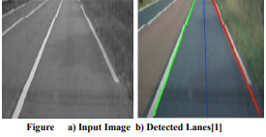

**4.2 Results using Hough Transformation and Filters**

T.T Tran et al in his analysis paper planned associate degree adaptative methodology supported HSI color model to find lane marking. First, they reborn RGB-based image to its HSI-based image. However, HSI color model was improved by the amendment within the thanks to calculate the intensity (I) part from RGB color pictures. From observant the colour pictures of the road scene in HIS color house, they used the restricted vary of color. Hence, H, S and that i part were employed in this methodology. The planned methodology will label the placement of lane marking accurately.

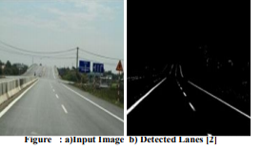

**4.3 Results of Lane Detection b 8ased on HSI model**

S. Srivastava et. al. in his analysis paper planned associate degree economical ways in which of noise reduction within the pictures by exploitation totally different filtering techniques during this paper. the most objective was to style, develop, implement associate degreed later on simulate an economical lane detection formula which can give prime quality leads to the case once noise is gift within the signal. numerous filters used for comparison were median, wiener, and hybrid median filters.

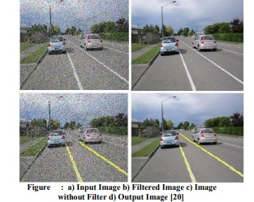

|  |  |  |  |  |
| --- | --- | --- | --- | --- |
| AUTHOR | Method | Problem addressed | Feature | Drawbacks |
| D. Pomerleau,2003[1] | “R.A.L.P.H.” | Self driven vehicles were not maintaining lane. | Lateral position detection. | Efficiency. |
| J. W. Lee, C. D. Kee, and U. K. Yi,2003[2] | “A new approach for lane departure identification.” | Lane departure identification. | Lane departure identification. | Other better ways were later invented. |
| J. W. Lee and U. K. Yi,2005[3] | “A lane-departure identification based on LBPE.” | Lane departure identification. | Lane departure identification. | Later other better ways were discovered. |
| Zu Whan Kim,2008 [4] | “Robust lane detection and tracking in Challenging Scenarios.” | Mathematically lane detection were carried out. | Lane detection. | LQE were having errors. Later geometry was preferred. |
| C. J. Chen, B. Wu, W. H. Lin,2009 [5] | “Mobile lane departure warning system.” | Mobile lane (service lane) warning system. | Service lane and their cautions detected. | Wasn’t compatible with any of lane detection. |
| Q.Lin and Y.Han, 2010[6] | “Extended edge linking algorithm ” | Real time lane detection departure. | Extended edge linking algorithm with real time lane detection was implemented. |  |
| H. Xu and H. Li,2010 [7] | “Study on a robust approach of lane departure warning algorithm” |  |  |  |
| J.-G. Wang, C.-J. Lin, and S.-M. Chen,2010[8] | “Fuzzy method to vision based lane detection” | Lane detection in it’s early days. | Fuzzy method for lane detection. |  |
| H. Xu and H. Li,2010 [9] | “Study on a robust approach of lane departure warning algorithm.” | Lane departure warning and alerting. | Lane departure warning. | Power distribution was causing faults. |
| Jiang Ruyi Klettee Reinhard 2011[10] | “Lane Detection and Tracking Using New Lane Model.” | Lane detection and tracking for faded lanes. | Lane detection using new lane model. | Reliability issues were faced. |
| H. Aung and M. H. Zaw,2011 [11] | “Video based lane departure warning system using hough transform.” | Video based lane detection was the safest and most successful as of now. | No extra mathematical OR electrical complexed devices were needed. | Currently most reliable type of lane detection. |
| Dan Revi and Guy Raz,2011 [12] | “Recent Progress in Lane and Road Detection.” |  |  |  |
| Zaier Zaidi, Essam Radwan and Rami Harb,2012 [13] | “Evaluating Variable Speed Limits and Dynamic Lane Merging Systems in Work Zones: A Simulation Study.” | Variable speed and Lane merging were tackled in simulation. | Variable speed limits. | Simulation was only successful. |
| Ni Wei and Ma Wanjing, 2013[14] | “Simulation Based Study on Lane Assignment Approach for Freeway Weaving Section.” | Improving operations on freeway weaving. | LAA: A New Lane control method was proposed. | Only simulation work is successful. |
| S. Srivastava, M. Lumb, and R. Singal, 2014[15] | “Lane detection using Hybrid Median” | Real Time lane detection. | Hybrid median method for lane detection. |  |
| S.-C. Huang and B.-H. Chen,2014 [16] | “Automatic moving object extraction through a real-world variable-bandwidth network.” | Traffic detection and computation. | Made automatic cars to move in traffic possible. | Was not 100% successful. And in such cases we need 100% result. |
| P.N Bhujbal and S.P Narote, 2015[17] | “Influence of lane departure.” | Self driven cars’ alarm system in case of crossing danger line, prone to accident. | Lane defence line departure warning system based on HOUGH TRANSFORM. | Light or Faded lanes were not rightly detected. |
| F. Yua, Z. Fang and Y. Fang,2015[18] | “Image and Smoke detection” | Automated machine was directly running into smoke/fire. | Detects smoke and images to make your ride more secure. | Anticipated smoke as human figure sometimes. |
| J. Niu, J. Lu, M. Xu, P. Lv, and X. Zhao,2015[19] | “Robust Lane Detection using Two-stage Feature Extraction.” | Two lane detection using robust lane detection. | Two lane detection system. | Failed in multiple lane roadways. |
| Dinesh Kumar, 2015[20] | “Lane Detection Techniques: A REVIEW.” |  |  |  |
| M.C Chuang and J.K Hwang, 2016[21] | “Object recognition system for underwater fish images.” | For underwater self driven system fish and other structures were not recognised. | Fish and underwater objects were recorded and processed. | Safe distance for detecting object was not enough. |
| Y.Saito and M.Itoh, 2016[22] | “Driver assistance system with dual control scheme.” | Dual control scheme was needed for extra ordinary situations. | Dual  assistance scheme was implemented effectively for driver assistance. |  |
| A. Mammeri, A. Boukerche, and Z. Tang,2016[23] | “A real-time lane marking localization, tracking and communication system.” | Lane localization, lane tacking and communication. | Communication and tracking | Enough battery backup couldn’t be created. |
| J.Navvaro, J.Deniel, E.Yousfi, C.Jallalis, M.Bueno, A.Fort, 2017[24] | “Influence of lane departure.” | Self driven cars’ alarm system in case of crossing danger line, prone to accident. | Lane defence line departure warning system. | Bugged Alarm system. |
| C.Y Kuo, Y.R Lu and S.M Yang, 2019[25] | “On the Image Sensor Processing for Lane Detection and Control in Vehicle Lane Keeping System.” | Very cost effective lane detection system. | Records the nearby environment and perceive it for your safety. | Rugged ground and light conditions were areas where it failed. |
| Aditya Singh Rathore, 2019[26] | “Lane Detection for Autonomous Vehicles using Open CV Library.” | Cartesian coordinates were rejected as they didn’t give appropriate value of slope. | Polar Coordinates were used. | Not 100% successful. |

1. **Paper Description**

**5.1 Goal**

The goal of this paper is to make up an easy image pipeline (take a frame from video as AN input, do one thing, come back a changed version of the frame), that permits detective work lane lines in easy conditions: sunny weather, smart visibility, no cars visible, solely straight lanes. another thing: our lane line detector ought to be linear.

Our main contribution during this paper is to try and do heaps of labor within the preprocessing stage. we have a tendency to planned to perform color rework of HSV within the preprocessing stage, then extract white, and so perform typical preprocessing operations in sequence. Moreover, we have a tendency to designated AN improved technique planned within the space of interest (ROI). during this paper, supported the planned preprocessing technique (after HSV color rework, white feature extraction, and basic preprocessing), simple fraction a part of the processed image is chosen because the space of interest (ROI). additionally, we have a tendency to performed double edge detection. the primary is within the preprocessing stage, and therefore the second is within the lane detection stage once the ROI is chosen. the aim of playacting double edge detection is to reinforce the lane recognition rate.

**5.4 Simlution**

The various steps concerned within the pipeline area unit as follows, every of those has additionally been mentioned in additional detail within the sub sections below:

•Compute the image/ video activity matrix and distortion coefficients given a collection of checkerboard pictures.

•Apply a distortion correction to raw pictures.

•Apply a perspective rework to rectify image ("birds-eye view").

•Use color transforms, gradients, etc., to make a thresholded binary image.

•Detect lane pixels and suitable realize the lane boundary.

•Determine the curvature of the lane and vehicle position with relation to center.

•Warp the detected lane boundaries back onto the initial image.

•Output visual show of the lane boundaries and numerical estimation of lane curvature and vehicle position.

**5.4.1 Generating a thresholded binary image**

Many techniques like gradient thresholding, thresholding over individual color channels of various color areas and a mixture of area unit to be experimented with over a coaching set of pictures with the aim of best filtering the lane line pixels from alternative pixels. The experimentation yielded the subsequent key insights:

1. The performance of individual color channels varied in detective work the 2 colors (white and yellow) with some transforms considerably outperforming {the alternative the opposite} s in detective work one color however showcasing poor performance once used for detective work the other. Out of all the channels of RGB, HLS, HSV and research laboratory color areas that were experimented with the below mentioned provided the best S/N and strength against varied lighting conditions:

• White constituent detection: R-channel (RGB) and L-channel (HLS)

• Yellow constituent detection: B-channel (LAB) and S-channel (HLS)

2. thanks to the uneven road surfaces and non-uniform lighting conditions a robust want for reconciling Thresholding is to be realized.

**5.5 Methods Used**

**5.5.1 Lane Line detection: Sliding Window technique**

A wrapped thresholded binary image wherever the pixels square measure either zero or one; zero (black color) constitutes the unfiltered pixels and 1 (white color) represents the filtered pixels. succeeding step involves mapping out the lane lines and determinative expressly that pixels square measure a part of the lines and that belong to the left line and that belong to the proper line.

The first technique used to try to to therefore is: Peaks in bar graph & slippery Windows

1. we have a tendency to initial take a bar graph on all the columns within the lower 1/2 the image. This involves adding up the component values on every column within the image. the 2 most distinguished peaks during this bar graph are smart indicators of the x-position of the bottom of the lane lines. These square measure used as beginning points for our search.

2. From these beginning points, we have a tendency to use a window, placed round the line centers, to search out and follow the lines up to the highest of the frame.

**5.5.2 Lane Line detection: Adaptive Search**

After police work the 2 lane lines, for future frames during a video, we'll search during a margin round the previous line position rather than performing arts a blind search.

Although the Peaks in bar graph and slippery Windows technique will an inexpensive job in police work the lane line, it typically fails once subject to non-uniform lighting conditions and discoloration. To combat this, a technique that might perform adjustive thresholding over a smaller receptive field/window of the image was required. The reasoning behind this approach was that performing arts adjustive thresholding over a smaller kernel would additional effectively filtrate our 'hot' pixels in varied conditions as hostile making an attempt to optimize a threshold price for the complete image.

**5.6 Applying Canny Detector**

The clever Detector could be a multi-stage algorithmic rule optimized for quick period of time edge detection. the elemental goal of the algorithmic rule is to sight sharp changes in light (large gradients), like a shift from white to black, and defines them as edges, given a collection of thresholds.

**5.6.1. Noise reduction**

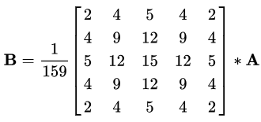

As with all edge detection algorithms, noise could be a crucial issue that always ends up in false detection. A 5x5 Gaussian filter is applied to flex (smooth) the image to lower the detector’s sensitivity to noise. this is often done by employing a kernel (in this case, a 5x5 kernel) of ordinarily distributed numbers to encounter the complete image, setting every component price adequate to the weighted average of its neighboring pixels.

**5.6.2. Intensity gradient**

The smoothed image is then applied with a Sobel, Roberts, or Prewitt kernel (Sobel is employed in OpenCV) on the coordinate axis and coordinate axis to sight whether or not the perimeters square measure horizontal, vertical, or diagonal.

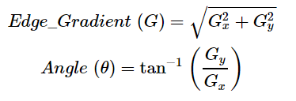

**5.6.3. Non-maximum suppression**

Non-maximum suppression is applied to “thin” and effectively sharpen the perimeters. for every component, the worth is checked if it's a neighborhood most within the direction of the gradient calculated antecedently.

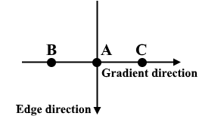

**5.6.4 Hysteresis thresholding**

After non-maximum suppression, sturdy pixels square measure confirmed to be within the final map of edges. However, weak pixels ought to be additional analyzed to work out whether or not it constitutes as edge or noise. Applying 2 pre-defined minVal and maxVal threshold values, we have a tendency to set that any component with intensity gradient on top of maxVal square measure edges and any component with intensity gradient under minVal aren't edges and discarded. Pixels with intensity gradient in between minVal and maxVal square measure solely thought of edges if they're connected to a component with intensity gradient higher than maxVal.

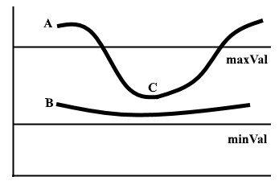

## ****5.6.5 Segmenting lane area****

We will handcraft a triangular mask to phase the lane space and discard the digressive areas within the frame to extend the effectiveness of our later stages.

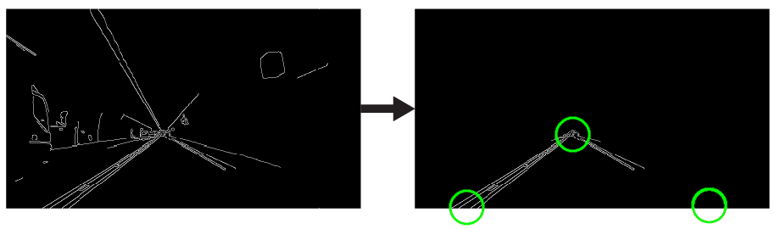

**5.6.6. Hough transform**

In the co-ordinate system, we will represent a line as y = magnetic flux unit + b by plotting y against x. However, we will additionally represent this line as one purpose in Hough house by plotting b against m. as an example, a line with the equation y = 2x + one could also be diagrammatical as (2, 1) in Hough house.

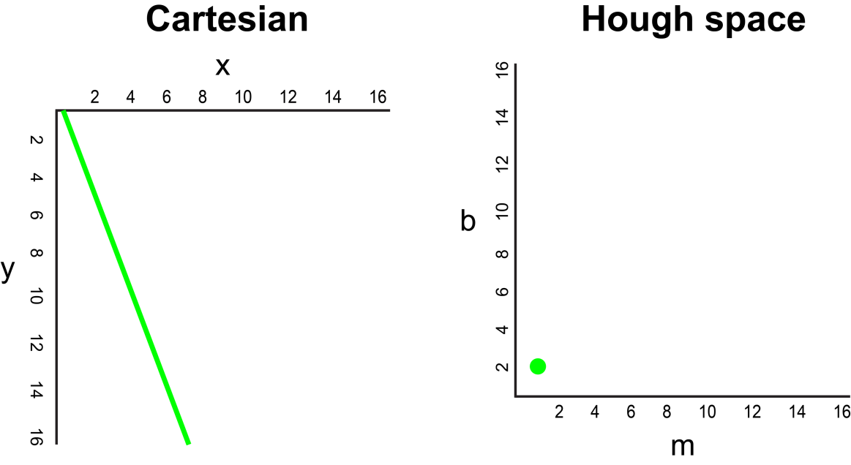

Now, what if rather than a line, we have a tendency to had to plot a degree within the co-ordinate system. There square measure several potential lines which may submit to now, every line with totally different values for parameters m and b. as an example, a degree at (2, 12) may be gone along y = 2x + eight, y = 3x + 6, y = 4x + 4, y = 5x + 2, y = 6x, and so on. These potential lines may be aforethought in Hough house as (2, 8), (3, 6), (4, 4), (5, 2), (6, 0). Notice that this produces a line of m against b coordinates in Hough house.

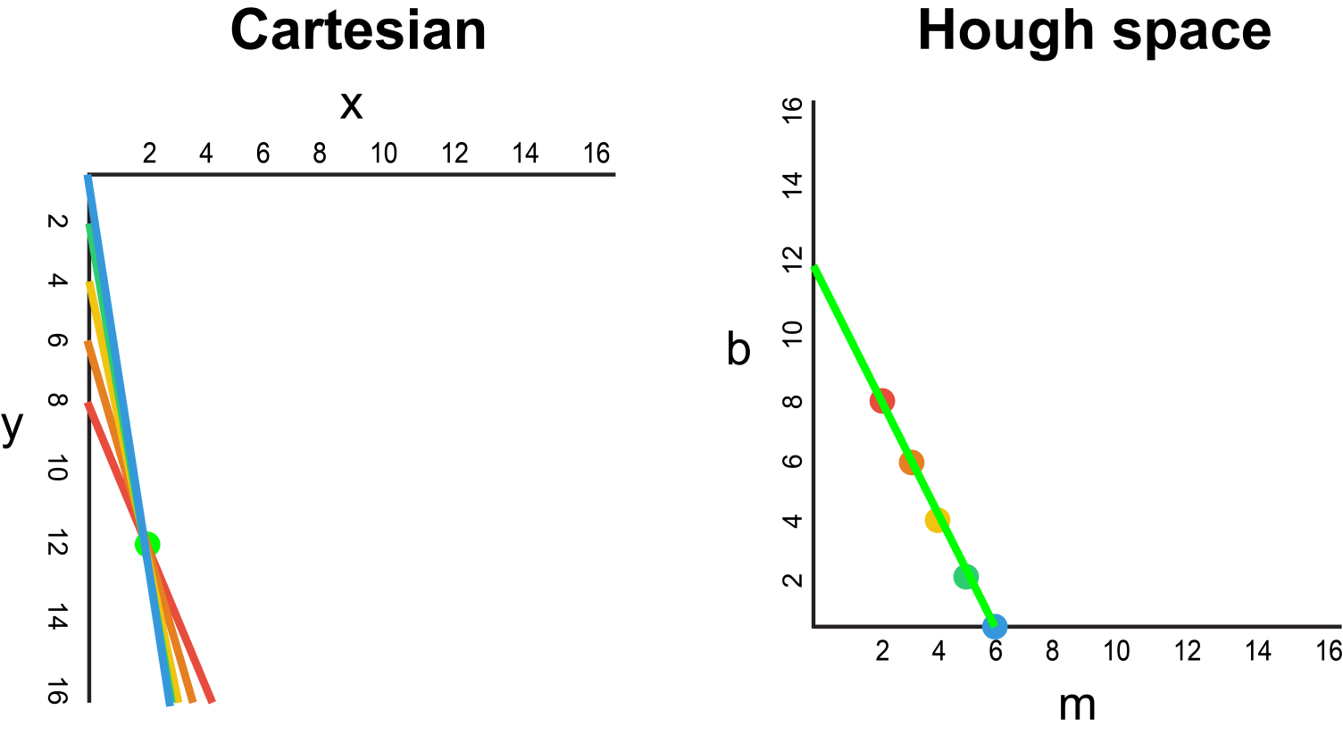

Whenever we have a tendency to see a series of points during a co-ordinate system and apprehend that these points square measure connected by some line, we will realize the equation of that line by initial plotting every purpose within the co-ordinate system to the corresponding line in Hough house, then finding the purpose of intersection in Hough house. the purpose of intersection in Hough house represents the m and b values that pass systematically through all of the points within the series.

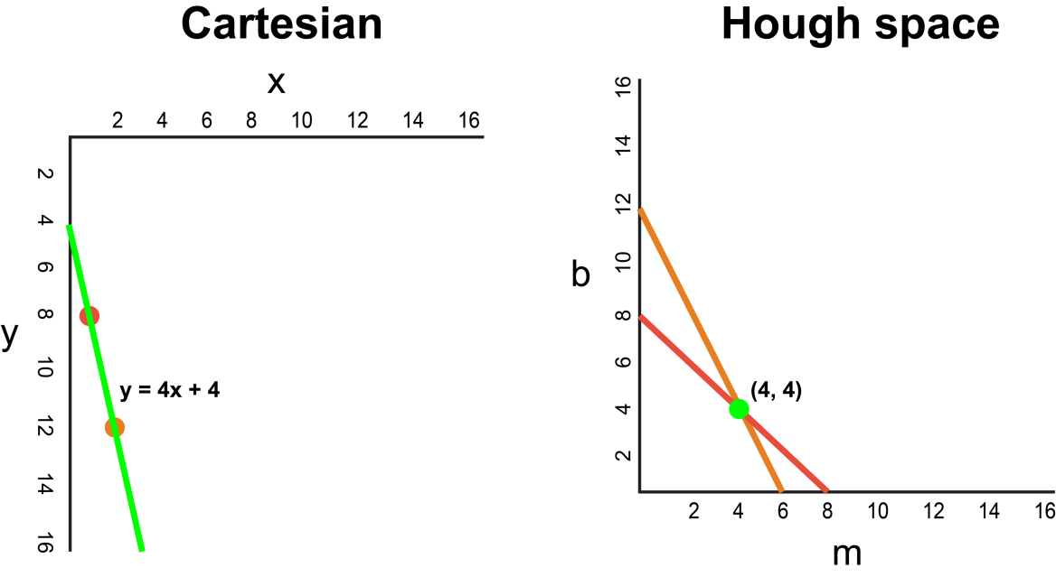

Since our frame tried and true the clever Detector could also be understood merely as a series of white points representing the perimeters in our image house, we can we will we square measure able to apply a similar technique to spot that of those points are connected to a similar line, and if they're connected, what its equation is so we will plot this line on our frame.

For the simplicity of explanation, we used Cartesian coordinates to correspond to Hough space. However, there is one mathematical flaw with this approach: When the line is vertical, the gradient is infinity and cannot be represented in Hough space. To solve this problem, we will use Polar coordinates instead. The process is still the same just that other than plotting m against b in Hough space, we will be plotting r against θ.

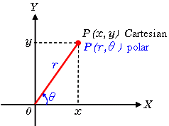

.

**5.6.7. Visualization**

The lane is visualized as two light green, linearly fitted polynomials which will be overlayed on our input frame.

1. **Specific Requirements**

Functional Requirements

•The lane lines are mapped from the road which are a result of determination of pixels which would be a part of the right and left lines of the lane.

•A way which would help to reduce traffic problems as lesser changing of lanes would take place.

•A method which would combine for the concept of self-driving cars.

**Flow Diagram**

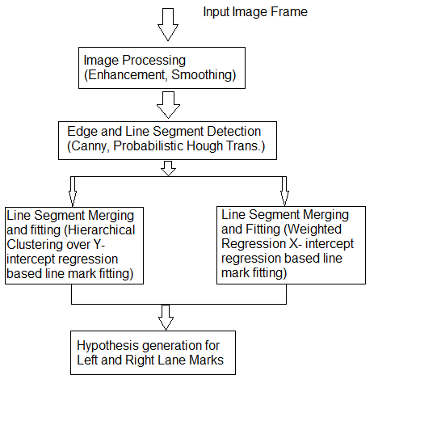

**Block Diagram**

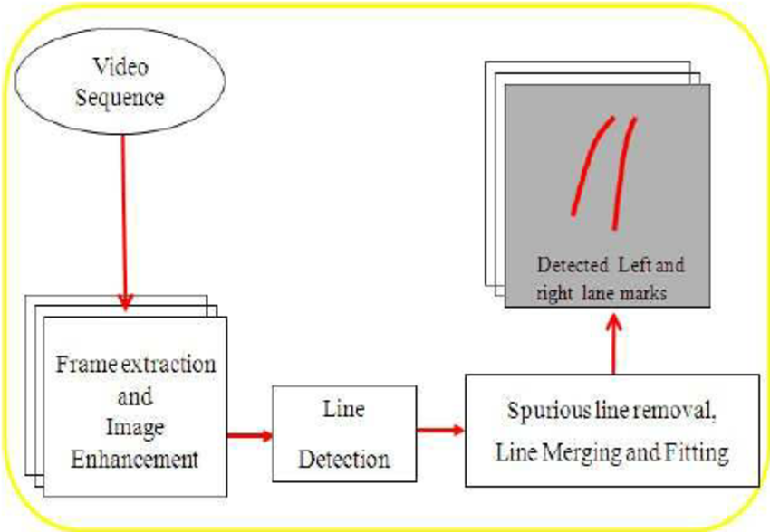

1. **Limitations**

* A recorder system to check the utility of the software on road and along with physical conditions is unavailable.
* A running concept of research which is not accepted widely in the current world scenario.

1. **Issues and Challenges**

* Only simulation of the concept was successful no practical application was made possible to work.
* Light and faded lines were not recognized efficiently by the system.
* Failed while working on multiple lane roads.
* Rough ground and Rugged roads provided problems to detect lanes for the system.
* A cent percentage result was not achieved and the practical applications need a 100% success rate.

1. **Conclusion**

In this paper we tend to planned a brand-new lane detection preprocessing and ROI choice ways to style a lane detection system. the most plan is to feature white extraction before the standard basic preprocessing. Edge extraction has conjointly been adscititious throughout the preprocessing stage to boost lane detection accuracy. we tend to conjointly placed the ROI choice once the planned preprocessing. Compared with choosing the ROI within the original image, it reduced the non-lane parameters and improved the accuracy of lane detection. Currently, we tend to solely use the Hough remodel to notice straight lane and track lane and don't develop advanced lane detection ways. within the future, we'll exploit a lot of advanced lane detection approach to boost the performance.

**References**

1. D. Pomerleau, “RALPH: rapidly adapting lateral position handler,” in Proceedings of the Intelligent Vehicles '95. Symposium, pp. 506–511, Detroit, MI, USA, 2003.
2. J. W. Lee, C. D. Kee, and U. K. Yi, “A new approach for lane departure identification,” in Proceedings of the IEEE IV2003 Intelligent Vehicles Symposium, pp. 100–105, 2003.
3. J. W. Lee and U. K. Yi, “A lane-departure identification based on LBPE, Hough transform, and linear regression,” Computer Vision and Image Understanding, vol. 99, no. 3, pp. 359–383, 2005.
4. Zu Whan Kim “Robust Lane Detection and Tracking in Challenging Scenarios” March 2008.
5. C. J. Chen, B. Wu, W. H. Lin, C. C. Kao, and Y. H. Chen, “Mobile lane departure warning system in,” in Proceedings of the 2009 IEEE 13th International Symposium on Consumer Electronics, pp. 1–5, 2009.
6. H. Xu and H. Li, “Study on a robust approach of lane departure warning algorithm,” in Proceedings of the EEE International Conference on Signal Processing System (ICSPS), pp. 201–204, 2010.
7. J.-G. Wang, C.-J. Lin, and S.-M. Chen, “Applying fuzzy method to vision-based lane detection and departure warning system,” Expert Systems with Applications, vol. 37, no. 1, pp. 113–126, 2010.
8. Q. Lin, Y. Han, and H. Hahn, “Real-Time Lane Departure Detection Based on Extended Edge-Linking Algorithm,” in Proceedings of the 2010 Second International Conference on Computer Research and Development, pp. 725–730, Kuala Lumpur, Malaysia, May 2010.
9. H. Xu and H. Li, “Study on a robust approach of lane departure warning algorithm,” in Proceedings of the IEEE International Conference on Signal Processing System (ICSPS), pp. 201–204, 2010.
10. H. Aung and M. H. Zaw, “Video based lane departure warning system using hough transform,” in Proceedings of the International Conference on Advances in Engineering and Technology, pp. 85–88, Singapore, 2010.
11. Jiang Ryui “Lane detection and tracking Using a New Lane Model and Distance Transform”, January 2011.
12. Zaier Zaidi, “Evaluating Variable Speed Limits and Dynamic Lane Merging Systems in Work Zones: A Simulation Study” May 2012.
13. Ahron Bal Hilel, Ronnen Lener “Recent Progress in Road and Lane Detection: A Survey.”, December 2011.
14. Ni Wei and Ma Wanjing “Simulation Based Study on a Study Lane Assignment Approach for Freeway Weaving Section.” 2013.
15. S. Srivastava, M. Lumb, and R. Singal, “Improved lane detection using hybrid median filter and modified Hough transform,” International Journal of Advanced Research in Computer Science and Software Engineering, vol. 4, no. 1, pp. 30–37, 2014.
16. S.-C. Huang and B.-H. Chen, “Automatic moving object extraction through a real-world variable-bandwidth network for traffic monitoring systems,” IEEE Transactions on Industrial Electronics, vol. 61, no. 4, pp. 2099–2112, 2014.
17. F. Yuan, Z. Fang, S. Wu, Y. Yang, and Y. Fang, “Real-time image smoke detection using staircase searching-based dual threshold AdaBoost and dynamic analysis,” IET Image Processing, vol. 9, no. 10, pp. 849–856, 2015.
18. P. N. Bhujbal and S. P. Narote, “Lane departure warning system based on Hough transform and Euclidean distance,” in Proceedings of the 3rd International Conference on Image Information Processing, ICIIP 2015, pp. 370–373, India, December 2015.  V. Gaikwad and S. Lokhande, “Lane Departure Identification for Advanced Driver Assistance,” IEEE Transactions on Intelligent Transportation Systems, vol. 16, no. 2, pp. 910–918, 2015.
19. Dinesh Kumar and Gurveen Kaur “Lane Detection Techniques: A Review.” Feb 2015
20. J. Niu, J. Lu, M. Xu, P. Lv, and X. Zhao, “Robust Lane Detection using Two-stage Feature Extraction with Curve Fitting,” Pattern Recognition, vol. 59, pp. 225–233, 2015.
21. M.-C. Chuang, J.-N. Hwang, and K. Williams, “A feature learning and object recognition framework for underwater fish images,” IEEE Transactions on Image Processing, vol. 25, no. 4, pp. 1862–1872, 2016.
22. Y. Saito, M. Itoh, and T. Inagaki, “Driver Assistance System with a Dual Control Scheme: Effectiveness of Identifying Driver Drowsiness and Preventing Lane Departure Accidents,” IEEE Transactions on Human-Machine Systems, vol. 46, no. 5, pp. 660–671, 2016.
23. A. Mammeri, A. Boukerche, and Z. Tang, “A real-time lane marking localization, tracking and communication system,” Computer Communications, vol. 73, pp. 132–143, 2016.
24. J. Navarro, J. Deniel, E. Yousfi, C. Jallais, M. Bueno, and A. Fort, “Influence of lane departure warnings onset and reliability on car drivers' behaviors,” Applied Ergonomics, vol. 59, pp. 123–131, 2017.
25. C.Y Kuo “On the Image Sensor Processing for Lane Detection and Control in Vehicle Lane Keeping Systems.” April 2019
26. Aditya Singh Rathore “Lane Detection for Autonomous Vehicle using OPEN CV Library”, January 2019.